Newsletter

Thursday,
May 17

201
87

School Values:

Respect

Teamwork

Persistence

Needs Basis Only | Middle Years Breakfast Club
Every Monday | Later Years Breakfast Club
Term 2 | Monday April 16 to Friday June 29
Friday Term 1, 2 & 4 | P-5 Swimming
Friday Term 1, 2 & 4 | Middle Years Swimming Cobden Indoor Pool
Each Friday April 27 to Friday May 18 | BRICKS (Building Resilience in Corangamite Kids)  Josh Hose Guest Inspirational Speaker TOMORROW.
Monday May 21 | Middle Years to Rockit Program – Respectful Relations Warrnambool CANCELLED
Monday June 11 | Queens Birthday Holiday Public Holiday
Friday June 15 | Later Years Trip to Melbourne Museum-Bugs Alive (deferred from Term 1 due to Bushfires)
TBA | Mock Interviews for Work Experience
Monday June 18 to Friday June 29 | Year 10 Work experience (2 weeks)
Friday June 29 | Final day of Term 2
In This Newsletter:
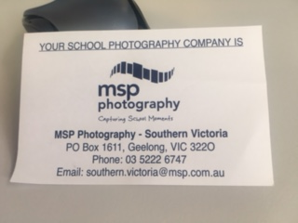
From the Principal
School Photos
Please note, families who did not get their orders into school can still order directly with MSP Photography as shown.
Glasses for kids P-3
Prep to Year 3 students were tested for glasses last Thursday. Every child will receive a report that will be given to families.
BRICKS (Building Resilience in Corangamite Kids) Josh Hose Guest Inspirational Speaker May 18
This Friday will be the final program of BRICKS for 2018. Josh Hose, a well-known ex-Camperdown resident and acclaimed International Wheelchair Rugby star will be our guest speaker. Josh is highly regarded for his ability to inspire young people to overcome adversity and be their best. We look forward to the privilege of having Josh address our students tomorrow. Thank you to Sally Wood for the excellent, very engaging and uplifting program she has delivered to of our students at Later Years over the previous four weeks.
Cobden Trade Training Centre Official Opening
The Cobden Campus of the Corangamite Trade Training Centre was officially opened today. Dan Tehan was the special guest at the ceremony.
Students attend this campus drawing from surrounding secondary schools. Courses offered at Cobden are Certificate 11 Building and Construction; Certificate 11 Automotive Vocational Preparation; and Certificate 11 Electrotechnology Studies.
Certificate 11 Agriculture is offered at the Derrinallum Campus;
Certificate 11 Salon Assistant as well as Cert 11 in Retail Make Up & Skin Care at Camperdown Campus; Certificate 11 in Hospitality; Engineering and Music at Timboon and;
Certificate 11in Community Services at Terang.
Hampden has one student attending Timboon this year one day per week.
Fire Update
I am pleased that all peat fires are now completely extinguished thus no further action is required in areas previously effected.
Combined Specialist Schools Cross Country CANCELLED
This event was cancelled due to poor weather and as it has not been possible to find a date that would suit all schools.
Regional Schools Victoria Cross Country – Deakin University Friday May 25
Sports Coordinators have been advised to enter any students who excel in this event in the regional Cross Country at Deakin. This event is scheduled for Friday May 25. Families of potential runners will be contacted individually.

EXTRA-CURRICULAR PROGRAMS
Rideability
Rideability is continuing to the end of term 2 with all Terang students participating each week.
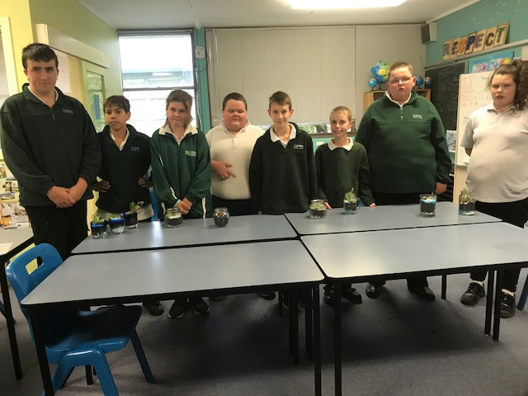
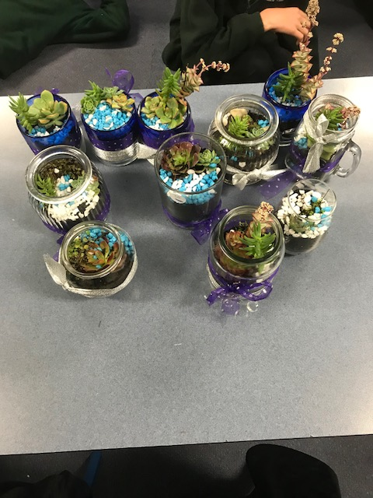
Middle Years Students enjoyed making terrariums for their special person on Mothers’ Day

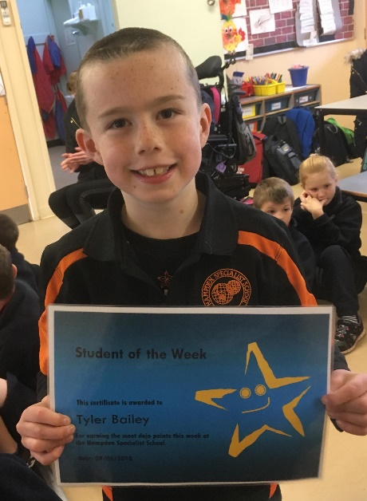
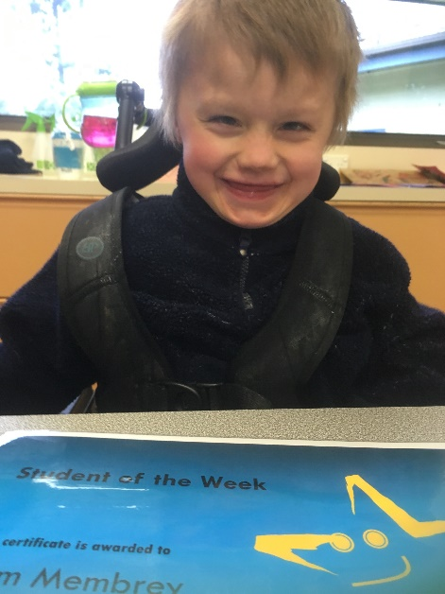
Tyler Bailey
Kalem Membrey

