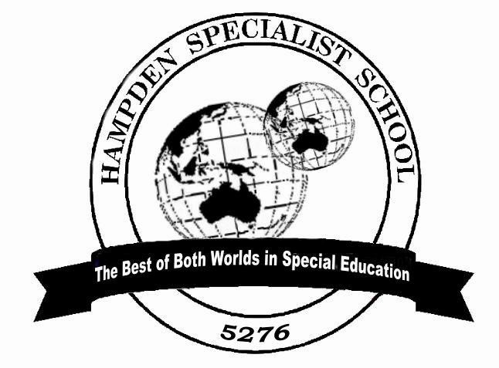

Newsletter

Thursday,
March 8

201
87

School Values:

Respect

Teamwork

Persistence

Every Monday & Friday | Middle Years Breakfast Club
Every Monday | Later Years Breakfast Club
Term 1 | Tuesday Jan 30 to Thursday March 29
Friday Term 1, 2 & 4 | P-5 Swimming
Friday Term 1, 2 & 4 | Middle Years Swimming Cobden Indoor Pool
Thursday March 8 | Middle Years to Sovereign Hill Ballarat
Friday March 9 &16 | Sailability at Hopkins River, Warrnambool
Monday March 12 | Labor Day holiday
Tuesday March 13 | Essendon Players Visit
Wednesday March 28 | Later Years to Melbourne Museum
In This Newsletter:
From the Principal
School Council Election
Glasses for Kids Program
Corangamite Youth Council representative
Extra Curricular Activities:
Sports Report
Parent Information session in Camperdown
Warrnambool Stingers Netball
From the Principal
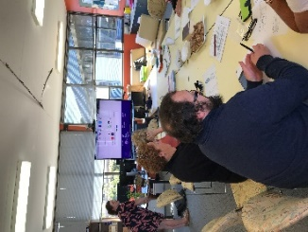
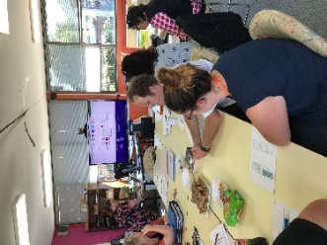
It was great to see so many of our parents attending Student Support meetings over the past week. Teachers and parents are working together to achieve the best outcomes for our students. Teachers have also be carrying out essential testing to assist with setting semester one learning goals and the results of this testing was shared with parents at the support meetings.
On Tuesday March 6th we were fortunate to have Emma Roberts from Cobden Primary School come to meet with our staff and provide training in the use of the Pat Reading test. Pat Reading is a new test we will use this year to assess how our students are going in reading comprehension, spelling and vocabulary.

School Council Elections
We are grateful to Judy Lucas, Leonie Meade, D’arne Paton and Kaylene Wright for nominating for the three school council positions in the parent category. An election is now in process with voting information and ballot papers distributed last Monday. Please take the time to return ballot papers to the office by close of polling at 4.00pm on Wednesday 14th March.

The ‘Glasses for Kids’ program coming to our school
The Glasses for Kids program will be visiting our school on Thursday May 10 to provide free (bulk-billed) comprehensive eye examinations and, if required a free pair of glasses for all Prep to Year 3 students.
This free initiative is a charitable partnership program delivered by State Schools’ Relief and its corporate and community partners, with the support of Department of Education and Training.
A qualified optometrist will be conducting testing session at our school assisted by final year optometry students from the University of Melbourne. They will conduct the tests in a specially equipped testing bus. If your child is identified as requiring glasses, glasses will be prescribed and fitted on the day and sent away for lenses to be fitted. Once ready, these will then be sent back to the school for your child.

Corangamite Youth Council representative
Our 2018 representative on the Corangamite Youth Council has been appointed. Following a successful application and interview process, Caytlyn Sharp will represent our school at these meetings. Youth Council actively plan activities and services for young people throughout the Corangamite Shire and make recommendations to Senior council. Caytlyn will do this very well and we thank her for taking this on.

EXTRA-CURRICULAR PROGRAMS

.
SPORTS REPORT
Our students have recently been involved in a variety of swimming and athletic sports. They have attended the Special Schools District swimming Sports in Warrnambool, District swimming Sports in Camperdown and Cobden Tech Athletic Sports. We had many ribbon winners, but more importantly, we congratulate all students who participated on their willingness to represent the school and have a go.

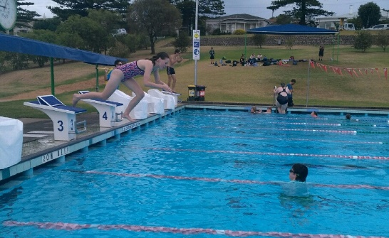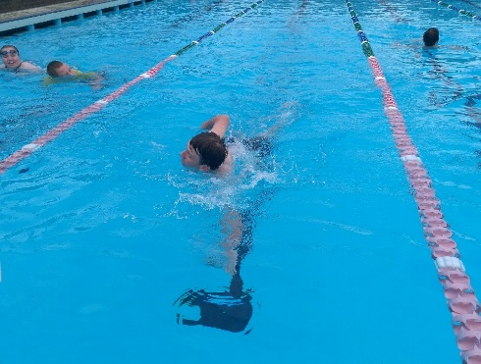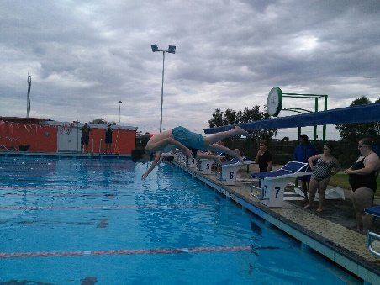
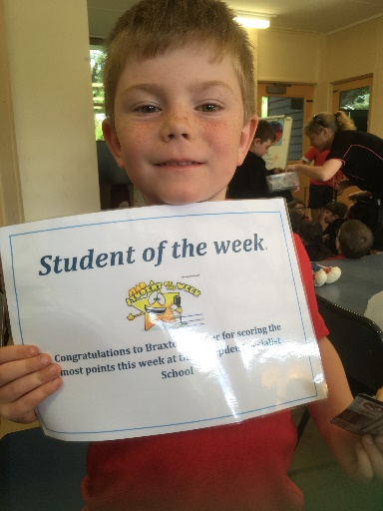
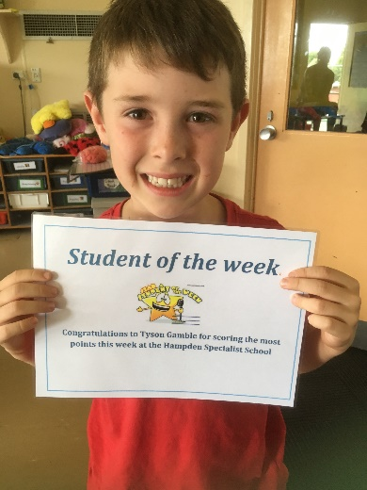
Braxton Simper
Tyson Gamble

