Newsletter

Thursday,
June 28

201
87

School Values:

Respect

Teamwork

Persistence

Needs Basis Only | Middle Years Breakfast Club
Every Monday | Later Years Breakfast Club
Thursday June 28 | Student Mid-year Reports Issued with Newsletter
Friday June 29 | Final day of Term 2 Early Closure Students Home One Hour Earlier Than Usual.
Monday July 16 | First Day Term 3
Wednesday July 25 | All Abilities Netball Carnival – Kardinia Park, Geelong – Later Years
Terang Campus Term 3 Winter Sports Program
Thursday 19th July & Thursday 26th July, Gymnastics, Springers- Warrnambool, Friday 3rd August & Friday 10th August Karate, Funakoshi- Warrnambool; Friday 17th August & Friday 24th August
Tennis, Warrnambool Indoor Tennis; Friday 31st August, Kidz Kingdom, Colac; Friday 7th & 14th September, Indoor Action Sports, Mortlake Road Warrnambool
Middle Years Winter Sports Program
Friday 20th, (July 27th – Special School Sports) July 3rd August 10th August – Tennis, Colac Indoor Tennis; August 17th – Tennis, Warrnambool Indoor Tennis; August 24th, 31st and September 7th Active Sportz September 14th Gymnastics, Springers, Warrnambool
Tuesday Term 3 | Later Years Swimming, Cobden Heated Pool
Friday July 27 | Special School Winter Sports at Warrnambool
Monday August 6 | Parent Teacher Meetings (PSGs) No Buses
Thursday September 13 | 2018 School Concert Commencing 7pm Venue TBA
Friday September 21 | Last Day Term 3 – 2pm Close

From the Principal
Reminder -Last Day of Term Tomorrow m- Early Finish, Students Home One Hour Earlier
School closes at 2pm tomorrow as it is the last day of term. Please ensure you are prepared for children to arrive home one hour earlier than the usual time.
Reminder – Student Mid-Year Reports Issued Today
Student Mid-Year Reports have been issued today. Once again I wish to heartily congratulate everyone who has contributed to the amazing successes I have witnessed and read about in Mid-Year Reports.
This year teachers have made a greater effort to explain to families how their child’s progress is assessed and how this information is used to set starting points for teaching.
At this school we use the same assessments that are used in other schools across the district as well as more detailed assessments. We want to ensure that we give our students the same opportunities as students in other schools and at the same time provide the highly individualised programs for which we are renowned.
Our Students have Spoken! There will be a Concert in Term Three!
Much deliberation has gone in to deciding whether we would host a concert this year due. Practices and prop preparation take a lot of time out of class-time and that means essential learning time. On the other hand we believe every student should have the opportunity to shine and ‘strut’ their stuff’ on the stage. There have been so many memorable performances and hidden talents we still talk about from previous concerts!
To solve the dilemma we decided to ask our students what they wanted. The result was that a concert would be held and all students wishing to take part would have the opportunity to do so. Therefore the 2018 Concert will be held on Thursday September 13 commencing at 7pm. Please put this important event in your diaries. The venue is yet to be announced.

EXTRA-CURRICULAR PROGRAMS
Rideability Footy Colours Breakup Last Thursday of Term, Today
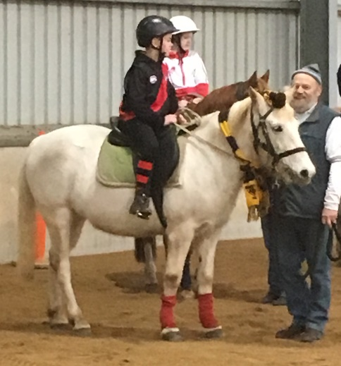
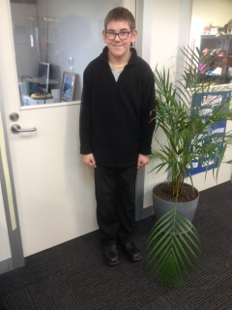
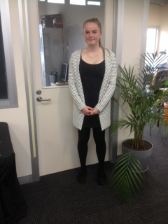
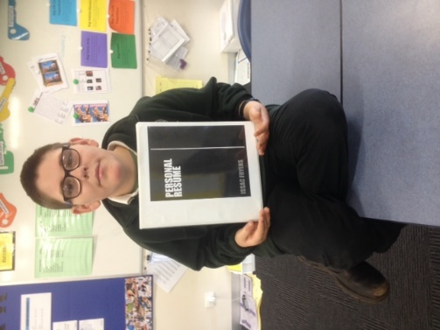
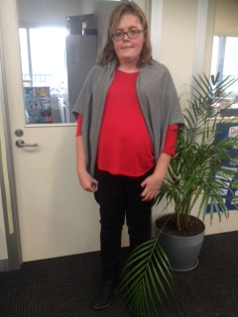
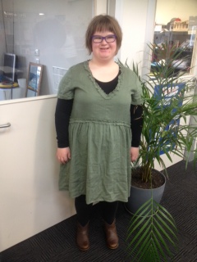
Thank you again to our amazing Rideability volunteers. These people are exceptional members of the community indeed. They go to incredible lengths to ensure their ponies are prepared and meet the stringent standards of a Rideability pony. They are also there every week in term one and two to offer our students a horse riding experience and all the advantages that flow from interacting with these ponies and these helpers. Thank you to all of these people.
Mock Interviews - In preparation for Work Experience mock interviews were conducted by WDEA staff

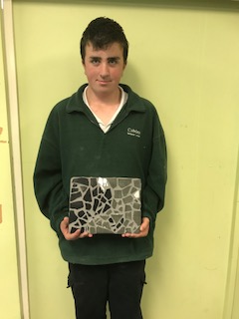
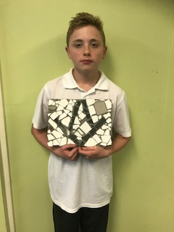
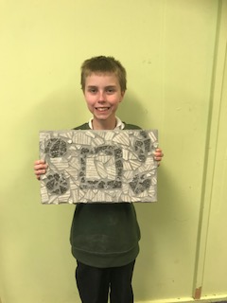
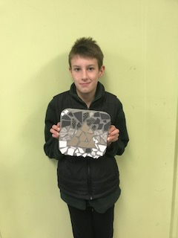
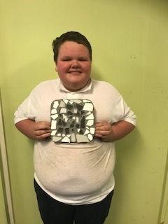
This semester middle years have been designing and creating their own tiling work using recycled materials and using their skills to create cushions in their sessions using textiles. Pictured are some of their finished products.

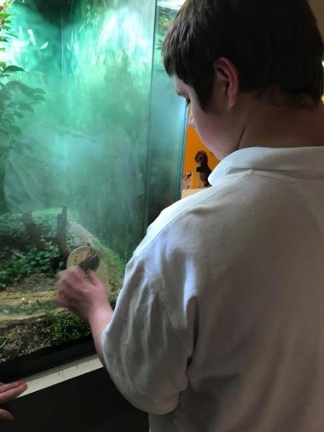
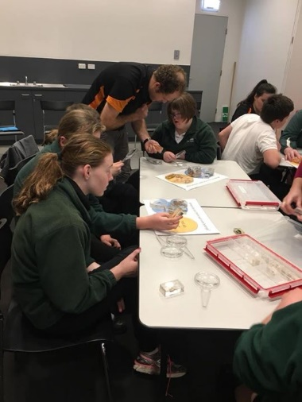
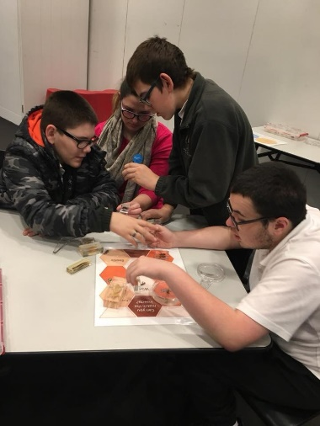
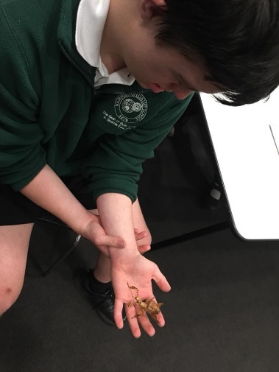
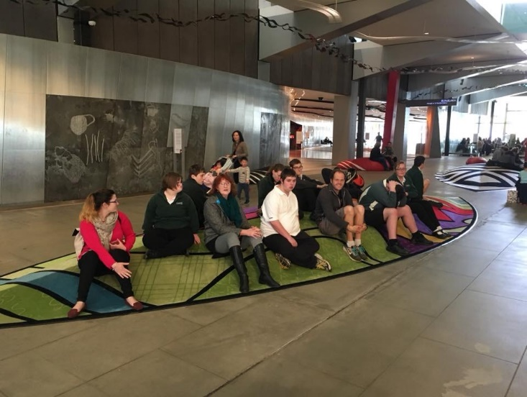
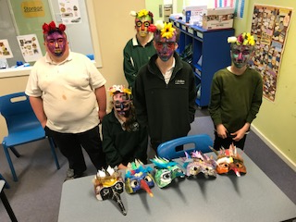

Melbourne Museum Visit.

The students had a half hour lesson on bugs, getting the opportunity to show the staff what they had learnt during their unit. The sorted through preserved insects, invertebrates and animals to categorise what an insect was. They had the chance to hold a giant stick insect and discuss how they are kept in captivity.
Next we were able to see the museum's vast array of preserved bugs and some live ones in simulated environments.
The students were able to explore the rest of the museum, a highlight for the boys being the giant dinosaur skeletons.
Art classes in middle years with Tash have seen students create two different mask designs. They have used a range of materials and techniques to make some very carefully constructed and colourful designs.
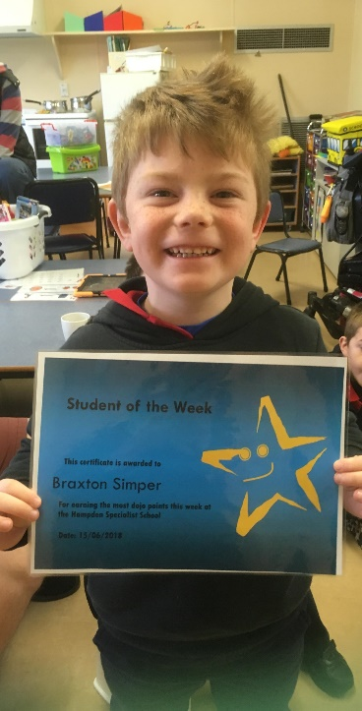
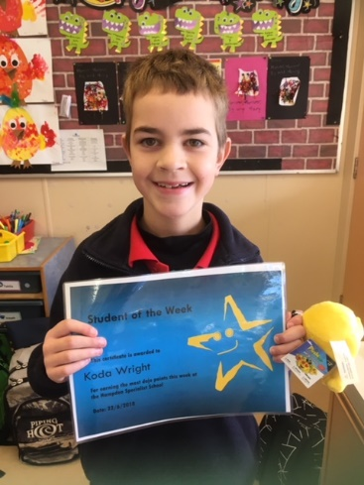
Braxton Simper
Koda Wright

