Newsletter

Thursday,
February 22

201
87

School Values:

Respect

Teamwork

Persistence

Every Monday & Friday | Middle Years Breakfast Club
Every Monday | Later Years Breakfast Club
Term 1 | Tuesday Jan 30 to Thursday March 29
Friday Term 1, 2 & 4 | P-5 Swimming
Friday Term 1, 2 & 4 | Middle Years Swimming Cobden Indoor Pool
Friday Feb 23 | Special Schools District Swimming Sports
Monday Feb 26 | Student Support group meetings-no buses
Thursday March 8 | Middle Years to Sovereign Hill Ballarat
Friday March 9 | Sailability
Monday March 12 | Labor Day holiday
Wednesday March 28 | Later Years to Melbourne Museum
In This Newsletter:
From the Principal
Mobile Phone Use
Earn and Learn
Our new microscopes
Corangamite Trade Training Centre

From the Principal
Term One continues to roll along and most timetables and programs are now established and underway. These include our valuable extra curriculum activities such as Rideability, Sailability, Meals on Wheels and community swimming programs. Our therapist staff have also begun work at both campuses and O.T. and speech assessments are taking place prior to development of programs for individual students.

Our school community was extremely sad to learn of the death recently of our long-time friend and Deb Ball dance instructor, Lesley Ellington. Lesley and her husband Trevor have coached our students at two Presentation Balls and forged wonderful friendships with students, families and staff at our school. The caring, kind and considerate way in which Lesley taught our young people not only dancing but important life skills will never be forgotten. We are holding Trevor and family in our thoughts and Lesley in our hearts.

Next Monday, February 26th has been put aside for Student Support Group Meetings. Your child’s teacher will be in touch to arrange a meeting time. Please make every effort to attend this short but valuable meeting to discuss your child’s goals for semester One.

Mobile Phone Use
Our students, like all teenagers these days, have a fear of missing out and like to be on their smart phones at all times. At school this creates social issues which have a negative effect on student learning. Just a recap of our school mobile phone policy:
Phones are permitted but must be on silent and out of sight.
If a phone is seen in class the teacher will request that it is handed in and it will be returned at the end of the day.
A student who is seen using their phone in class and refuses to hand it in on request may be sent home for the rest of the day.
Some tips for parents whose child has been involved in negative social situations on social media or in group-chats:
Phone bullies require someone to be listening so:
Only answer your phone to identified numbers.
Block numbers of people who are not friends.
If you find yourself in a toxic group chat hang up immediately and do not answer again.
Change the phone number if problem calls or texts persist.
Phones should not be in bedrooms overnight. Set a time (bedtime) and put all family phones on a charger in communal part of the house.
Parental example is very important: model responsible phone use to your child and never join in arguments or toxic discussions over the phone or on social media involving our child and other young people.
Thanks for your co-operation in keeping our students safe.

Earn and Learn
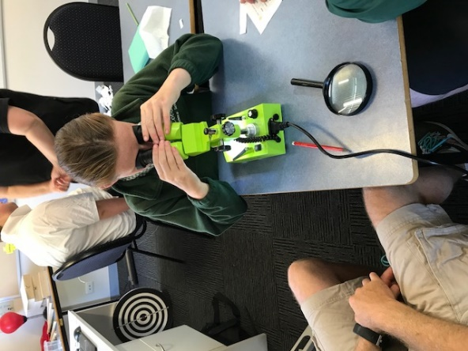
Our Earn and Learn reward goods have arrived. Each area of the school were able to redeem points collected for educational items from Modern Teaching Aids. Goods received included sporting equipment, games,
garden composter, weather vane and stationery items. Thanks again to all supporters of this valuable program.

Our New Microscopes
With funds raised through our very successful Christmas market last year we have purchased a set of microscopes for student use. Science is a priority area for Victorian students and these microscopes will make study of scientific concepts easier and fun. Later years students are currently investigating insects in Science.

Corangamite Trade Training Centre
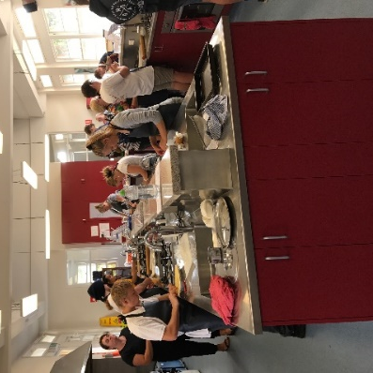
Every Thursday Angus goes to Corangamite Trade Training Centre in Timboon. There he does a Hospitality course. Angus would like to be a master chef, and this will help him reach his goals.

EXTRA-CURRICULAR PROGRAMS

.
Hampden Stars in the pool
Last week, on the 13th of February, 4 students from Hampden Specialist School participated in the Cobden Tech swimming sports at the Cobden swimming pool with brilliant results. Caytlyn Sharp had fantastic results coming 1st in freestyle and backstroke and 2nd in breaststroke. Zerik Felstead was awesome coming 2nd in freestyle and 3rd in backstroke. Cody Mulawa also did amazing coming 1st in freestyle and 2nd in 100m freestyle. Emma Daffy did brilliant as well completing 6 events coming 3rd in freestyle and backstroke, 5th in breaststroke, 2nd in butterfly, 1st in 100m freestyle and 1st in the freestyle relay. We’re not sure when the districts are but we are pretty sure that all 4 students will go into the districts. Well done to all competitors.

Emma Daffy.

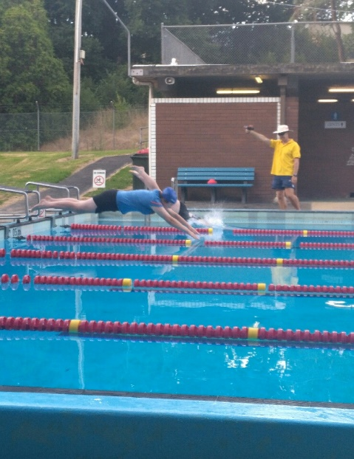
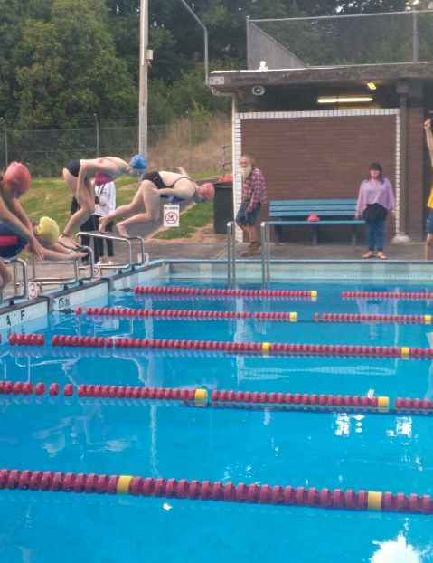
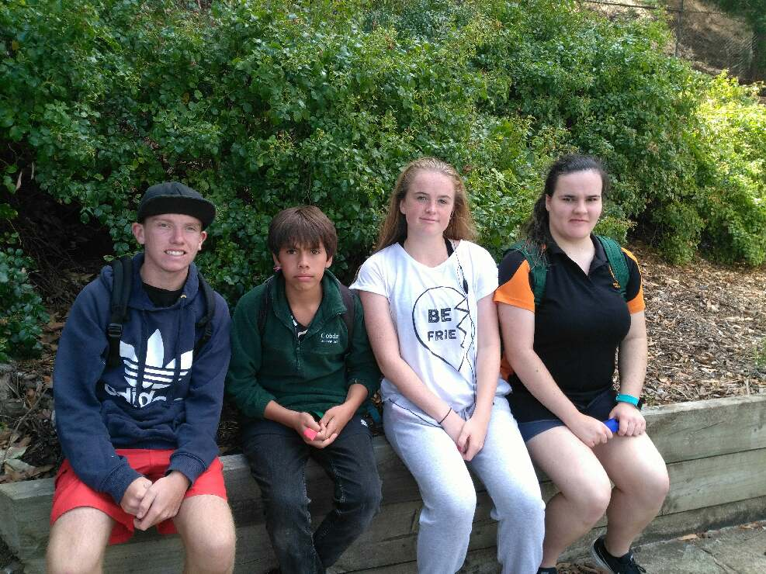

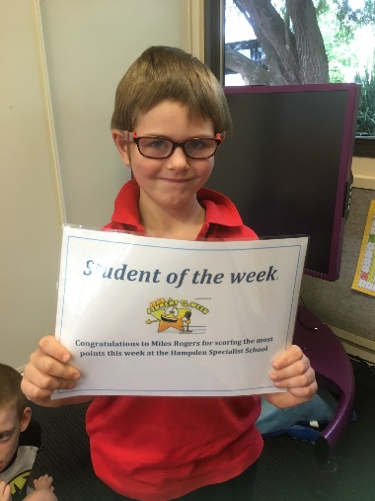
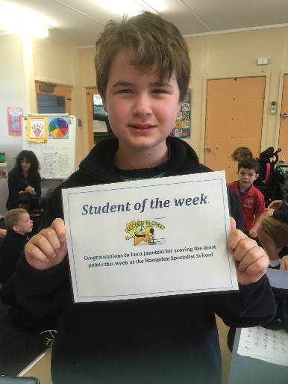
Stars of the Week
Miles Rogers
Luca Janetzki

